**Observ 2**: To each elementary row operation e, there corresponds an elementary row operation e-1 of the same type such that e-1(e(A)) = A. In other words, the process is reversible.**Prop3**: If A is a square matrix, then A is row equivalent to the identity matrix if and only if the homogeneous system AX = 0 has only the trivial solution.**Prop4 (Non Homo Sys)**: The system is consistent if and only if the rightmost column of R is not a pivot column, i.e. if there is no row of the form [0; : : : ; 0; b] with b nonzero.**Observ6**: A vector is a solution of the system AX = b if and only if it is of the form u + v, where v is a solution of the associated homogeneous system.**Prop5**: If e is an elementary row operation and E is the *mxm* elementary matrix e(Im), then for every *mxn* matrix A, e(A) = EA.**Prop6**: Every elementary matrix E is invertible, and E-1 is also an elementary matrix (of the same type).

**Theorem1**: The following are equivalent fors an *mxm* square matrix A:

(a) A is invertible.

(b) A is row equivalent to the identity matrix.

(c) The homogenous system AX = 0 has only trivial solution.

(d) The system of equations AX = b has a solution for every b in Rm.

(e) Nullity(A) = 0

(f) Rank(A) = m

(g) The Cols of A form a basis for Rm

(h) det(A) != 0

**Corollary 1.1**: An invertible matrix A is a product of elementary matrices. Moreover, any sequence of row operations that reduces A to I also transforms I into A-1.

**Corollary 1.2**: If A has a left inverse or a right inverse, then it has an inverse.

**Corollary 1.3**: Suppose a square matrix A is factored as a product of square matrices, i.e. A = A1A2 : : : An (all square matrices). Then A is invertible if and only if each Ai is invertible.

**Corollary 1.4**: (Alternative version of last equivalence in TIMT): The matrix A is invertible if and only if the system of equations AX = B has a unique solution for each and every vector b in Rm.

**Proposition 7**: Let V be a vector space. Then:

(a) The zero vector is unique, i.e. it has the zero vector.

(b) The additive inverse vector of any vector u is unique; we use the notation -u for the inverse vector.

(c) 0u = 0 for every vector u.

(d) a0 = 0 for every scalar a.

(e) -u = (-1)u for every vector u.

**Proposition 8**: A subset W of V is a subspace if and only if it satisfies the following three properties:

(i) The zero vector 0 is in W.

(ii) W is closed under addition. That is, for each u and v in W, the sum u + v is in W.

(iii) W is closed under scalar multiplication. That is, for each u in W, and each scalar c, the scalar product cu is in W.

**Proposition 10**: If S = {v1; v2; : : : ; ; vp} is a set of vectors in a vector space V, then Span S =Span {v1; v2; : : : ; ; vp} is a subspace of V.

**Corollary10.1**: Let V be a vector space.

(a) If U and W are two subspaces of V, then U∩W (i.e. the intersection of U and W) is also a subspace of V.

(b) If S = {v1; v2; : : : ; vp} is a set of vectors in a vector space V, then Span S = Span {v1; v2; : : : ; vp} is the smallest subspace which contains S, i.e. if W is a subspace such that SCW, then Span SCW.

**Linear Dependence**:

Remark 1: Any list which contains the 0 vector has to be linearly dependent. In fact, the single zero vector 0 is always linearly dependent (LD).

Remark 2: A single non-zero vector is linearly independent.

Remark 3: A list of two non-zero vectors is linearly dependent only if one of the vectors is a scalar multiple of the other.

Remark 4: A list of non-zero vectors is linearly dependent if and only if at least one of the vectors is a linear combination of the others.

Remark 5: Consequently, any list which contains a repeated vector must be linearly dependent. A list which is linearly independent corresponds to a set.

Remark 6: Any list which contains a linearly dependent list is linearly dependent or Superset of a linearly dependent set is linearly dependent.

Remark 7: Any subset of a linearly independent set is linearly independent.

**Definition**: Let V be a vector space over F. Then a subset BCV is a basis for V if

(i) B is a linearly independent and,

(ii) B spans (or generates) V i. e. V = Span B.

**Proposition 11**: B = {v1; v2; : : : ; vn} is a basis of the vector space V if and only if every vector v 2 V is uniquely expressible as a linear combination of the elements of B.

**Proposition 13**: If V is a finite-dimensional vector space, then any two bases of V have the same number of elements

**Proposition 14**: Suppose S = {v1; v2; : : : ; vn} is a linearly independent set in a vector space V. Suppose v is a vector which is not in Span S. Then the set obtained by adjoining v to S is linearly independent.

**Proposition 15**: Any linearly independent set S in a finite-dimensional vector space can be expanded to a basis.

**Proposition 16**: Any finite spanning set S in a non-zero vector space can be contracted to a basis

**Proposition 17**: Let V be a finite-dimensional vector space with dimension n. Then:

(a) Any subset of V which contains more than n elements is linearly dependent.

(b) No subset of V which contains less than n vectors can span V.

**Proposition 18**: If W is a proper subspace of a finite-dimensional space V, then W is also finite-dimensional and 0 < dimW < dimV.

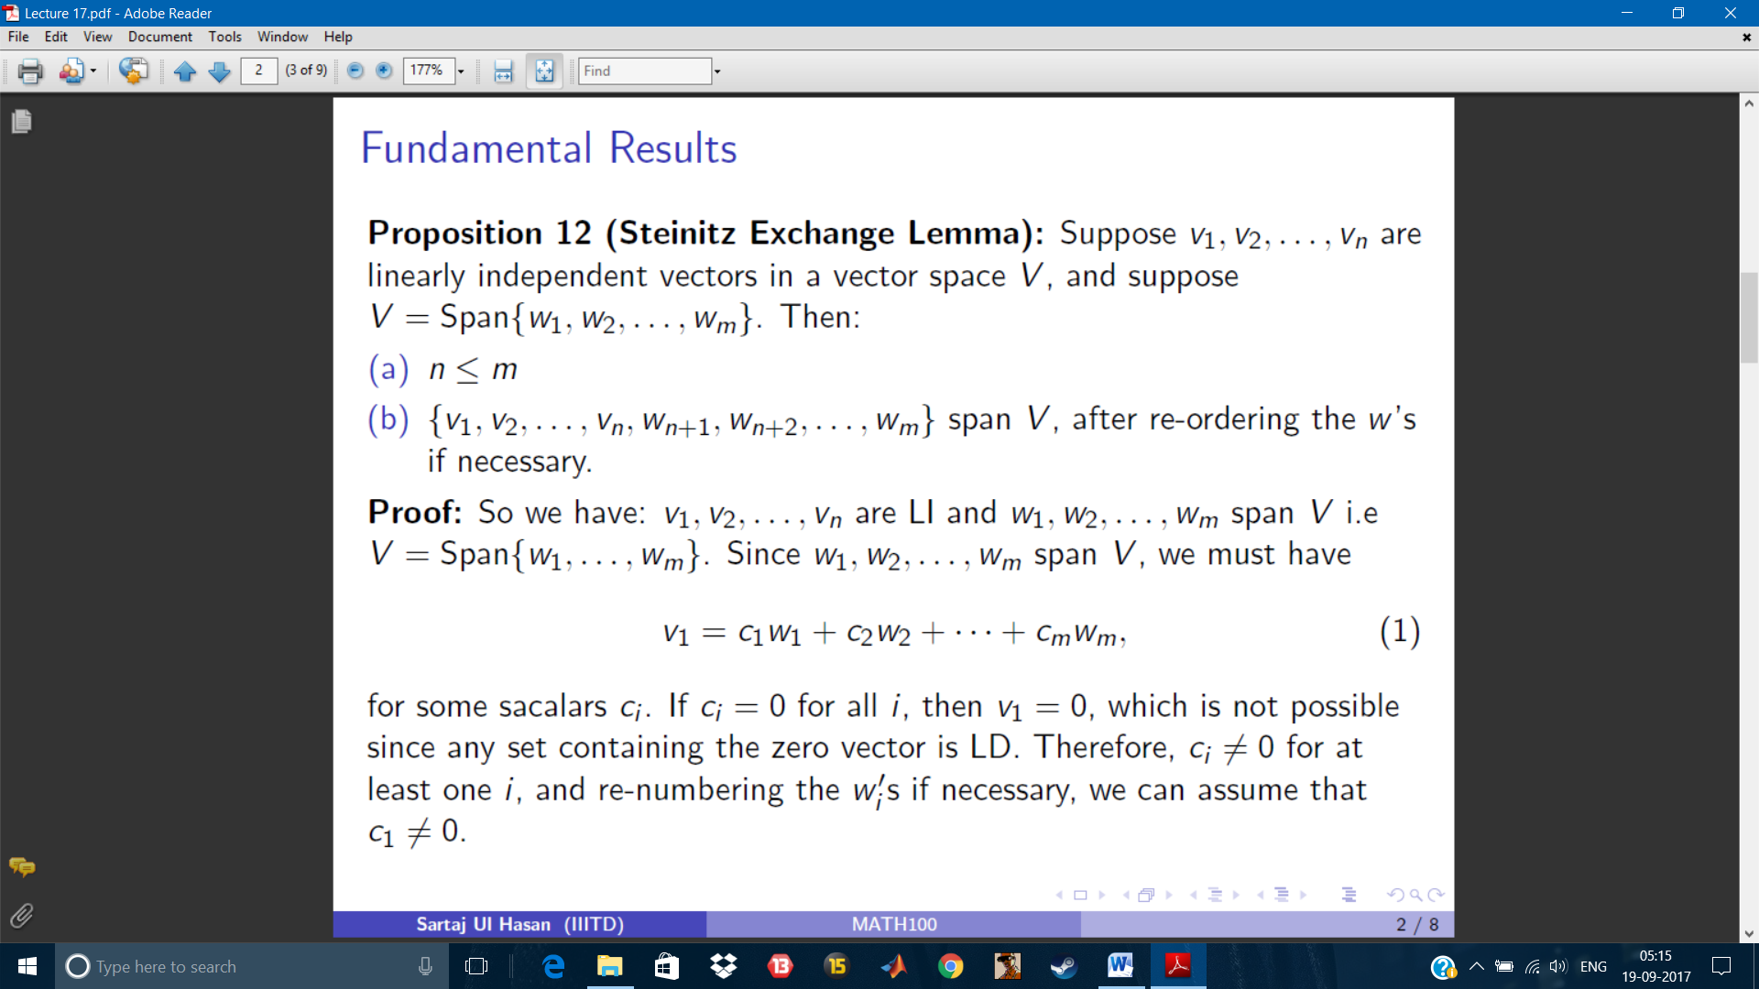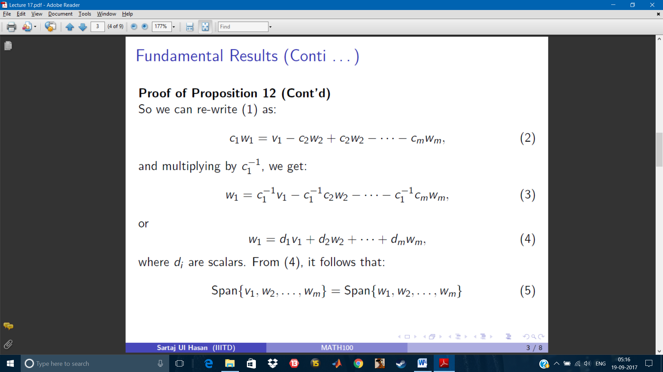

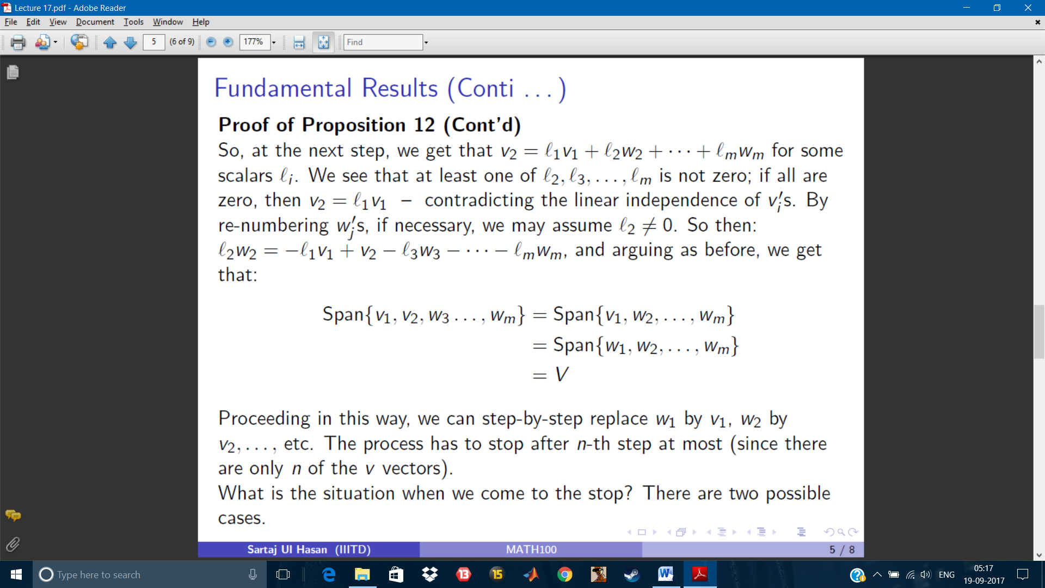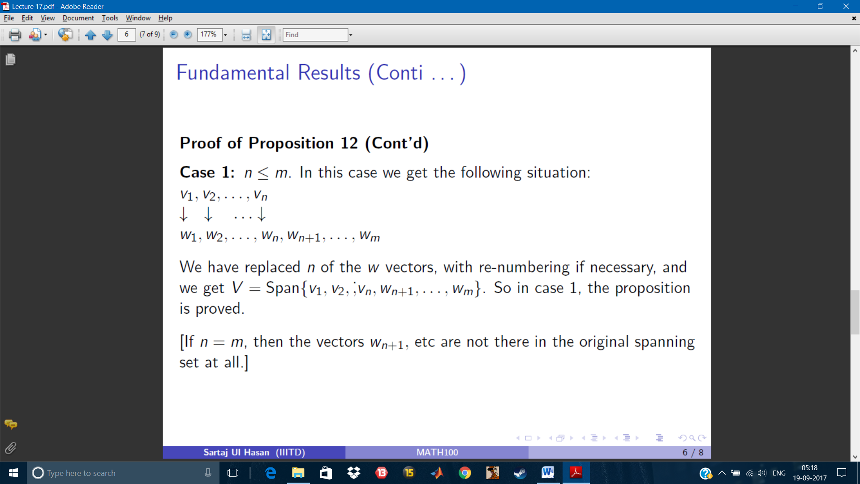

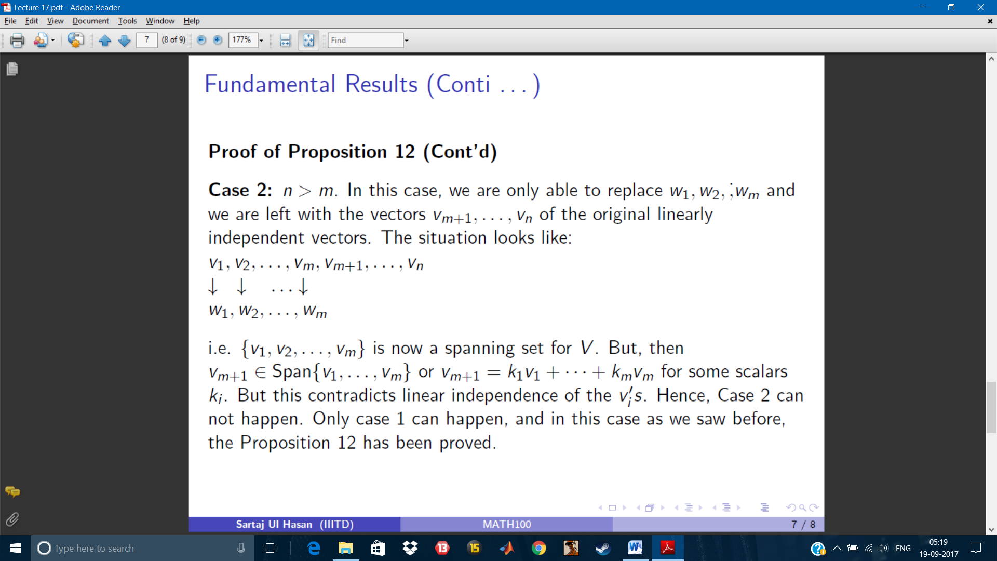

**Proposition 21:** The null space of an m _ n matrix A is a subspace of Rn. Or equivalently, the set of all solutions of a homogeneous system of m equations in n variables is a subspace of Rn.

Basis for Null A is the spanning set of the solutions.

**Definition 2:** The column space of an m _ n matrix A, written Col A, is the set of all linear combinations of the columns of A, i.e. the span of the column vectors obtained from A. If A = [c1; c2; : : : ; cn], then Col A = Span fc1; c2; : : : ; cng.

**Proposition 22:** Col A is a subspace of Rm.

**Proposition 23:** The pivot columns of a matrix A form a basis for Col A.

**Definition 3:** The row space of an m _ n matrix A, written as Row A, is the set of all linear combinations of the rows of A, i.e., the span of the (row) vectors obtained from A. In doing this, we consider each row as an n-tuple, and hence as a vector in Rn.

**Proposition 24:** Row A is a subspace of Rn.

Basis for Row A are non-zero rows of the RREF.